Argo Rollouts: Canary and Blue/Green rollouts.
Canary:
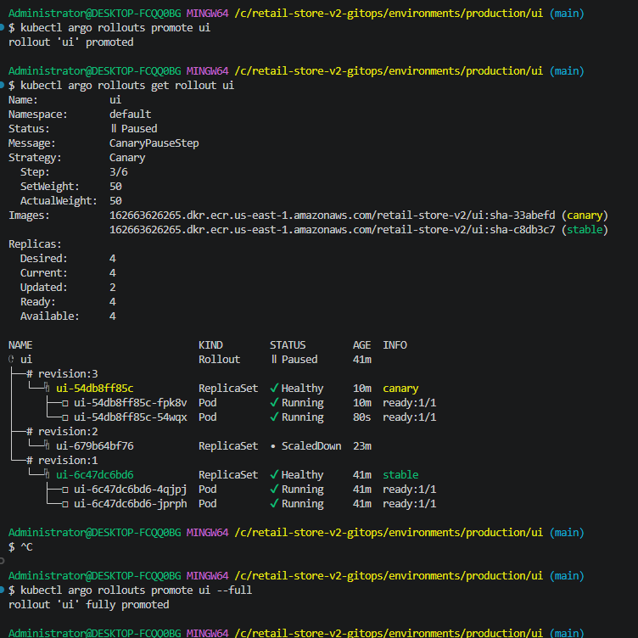
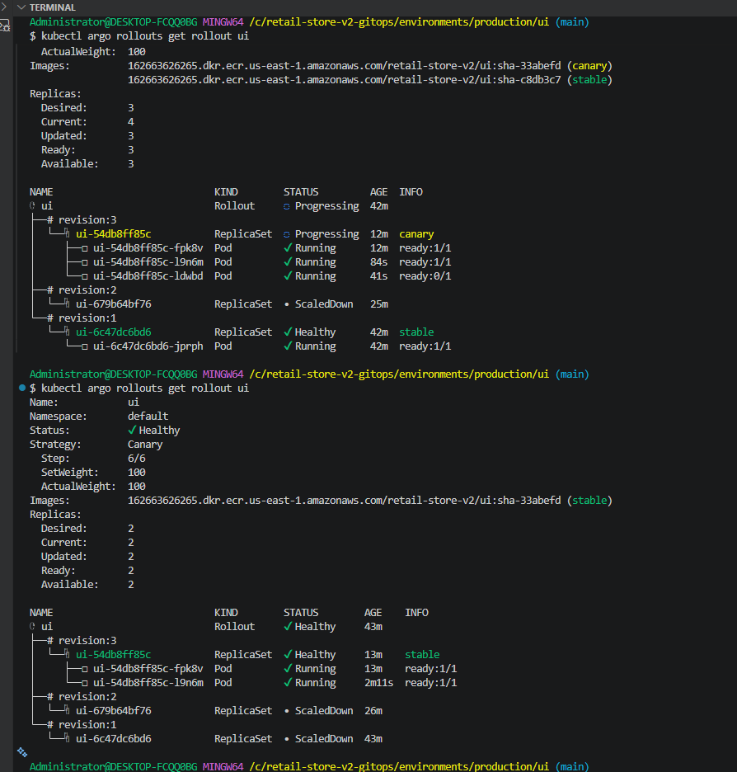
Canary rollout with ALB Traffic Routing
I integrated Argo Rollouts with the AWS Load Balancer Controller so the ALB managed weighted traffic between stable and canary target groups, allowing progressive delivery without relying on replica ratios.
AWS ALB Traffic Routing with Argo Rollouts Summary
Objective
Modernize the Retail Store v2 deployment strategy by replacing traditional rolling updates with Progressive Delivery using Argo Rollouts and the AWS Application Load Balancer (ALB).
Instead of immediately replacing every pod, new versions are introduced gradually while production traffic is shifted in controlled percentages.
GitHub Actions
│
▼
Amazon ECR
│
▼
GitOps Repository
(image tag updated)
│
▼
Argo CD Auto Sync
│
▼
Argo Rollouts
│
▼
AWS ALB
│
┌─────┴─────────┐
│ │
▼ ▼
Stable Service Canary Service
